1. SQL Statements used:
   1. create database PatientDatabase;
   2. show databases;
   3. use PatientDatabase;
   4. create table Medicine(Med_ID varchar(255) NOT NULL,Patient_ID int NOT NULL,Med_Name varchar(255),Start_Date date,Med_Price float,primary key (Med_ID));
   5. insert into Medicine values('ALCOHOL01', 142, 'ALCOHOL PREP PAD', '1998-09-12',5.99),('ALCOHOL02', 142, 'ALCOHOL 1.4% LIQUID', '2000-05-03',8.99),('ALCOHOL03', 142, 'ALCOHOL PREP PAD', '2006-11-08',11.99),('ASPIRIN01', 857, 'ASPIRIN 325MG TAB', '2006-06-08',4.99),('CISAPRIDE01', 857, 'CISAPRIDE 5MG TAB', '2000-07-25',3.49),('CISAPRIDE02', 857, 'CISAPRIDE 10MG TAB', '2004-03-18',3.49),('CISAPRIDE03', 857, 'CISAPRIDE MONOHYDRATE 5ML SUSP', '2004-12-01',4.49);
   6. show tables;
   7. select * from Medicine;
   8. drop table Medicine;
   9. drop database PatientDatabase;

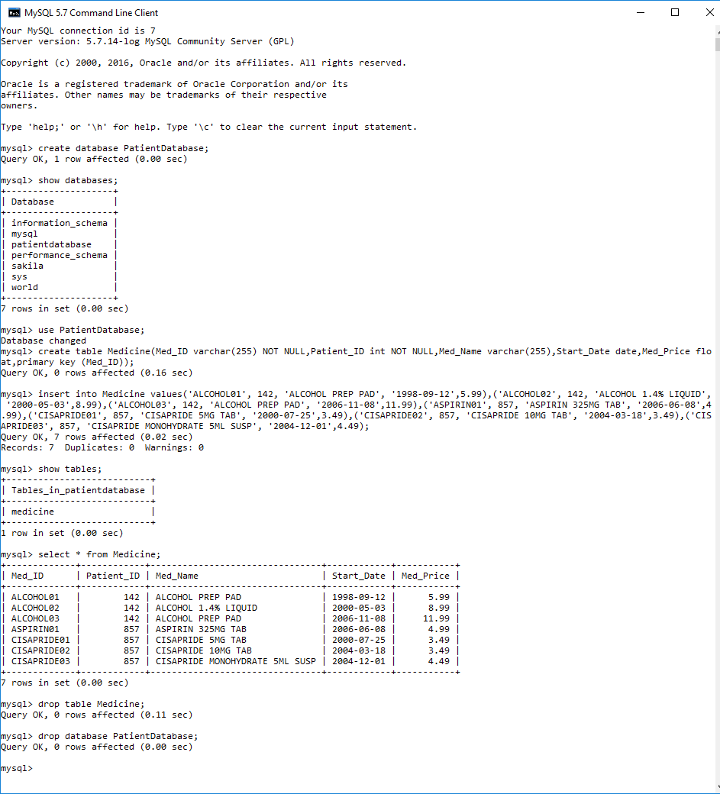

creat_db.bat file:

@ECHO off

::

:: Uses the MySQL monitor to run the SQL scripts that create

:: and populate the tables in the sample database.

"C:\Program Files\MySQL\MySQL Server 5.7\bin\mysql" -u root -p < "C:\Users\cvalle\Desktop\create_db.sql"

ECHO.

ECHO If no error message is shown, the databases named PatientDatabase was created successfully.

ECHO.

:: Display 'press any key to continue' message

PAUSE

creat_db.sql file:

/**************************************************************

* SQL script file used reate the database named PatientDatabase

* and all of its tables

**************************************************************/

DROP DATABASE IF EXISTS PatientDatabase;

CREATE DATABASE PatientDatabase;

USE PatientDatabase;

CREATE TABLE Patient (

Patient_ID INT NOT NULL,

Patient_Name VARCHAR(50),

Date_of_Birth DATE,

Height INT,

Weight INT,

PRIMARY KEY(Patient_ID)

);

INSERT INTO Patient

(Patient_ID, Patient_Name, Date_of_Birth, Height, Weight)

VALUES

(123, 'Milhouse', '1979-11-02', 63, 132),

(142, 'Bart', '1965-04-09', 71, 183),

(456, 'Ralph', '1974-10-21', 67, 201),

(857, 'Lisa', '1983-02-23', 67, 147);

create table Medicine

(

Med_ID varchar(255) NOT NULL,

Patient_ID int NOT NULL,

Med_Name varchar(255),

Start_Date date,

Med_Price float,

primary key (Med_ID),

foreign key Patient_ID(Patient_ID) references Patient(Patient_ID)

);

insert into Medicine values

('ALCOHOL01', 142, 'ALCOHOL PREP PAD', '1998-09-12',5.99),

('ALCOHOL02', 142, 'ALCOHOL 1.4% LIQUID', '2000-05-03',8.99),

('ALCOHOL03', 142, 'ALCOHOL PREP PAD', '2006-11-08',11.99),

('ASPIRIN01', 857, 'ASPIRIN 325MG TAB', '2006-06-08',4.99),

('CISAPRIDE01', 857, 'CISAPRIDE 5MG TAB', '2000-07-25',3.49),

('CISAPRIDE02', 857, 'CISAPRIDE 10MG TAB', '2004-03-18',3.49),

('CISAPRIDE03', 857, 'CISAPRIDE MONOHYDRATE 5ML SUSP', '2004-12-01',4.49);

1. Running the SQL statements from assignment 1:

